**AWS DevOps : Sample For Create EC2 Instance using Terraform**

1. Download Terraform from https://www.terraform.io/downloads.html

2. Copy terraform.exe file as installation file.

3. Set path in environment variable to installation file of terraform.

Open google and search ‘create instance using terraform’

Click on below link-

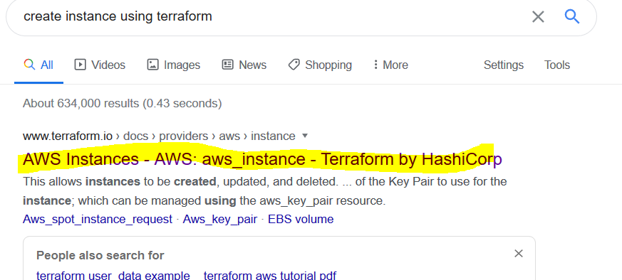

Copy below code –

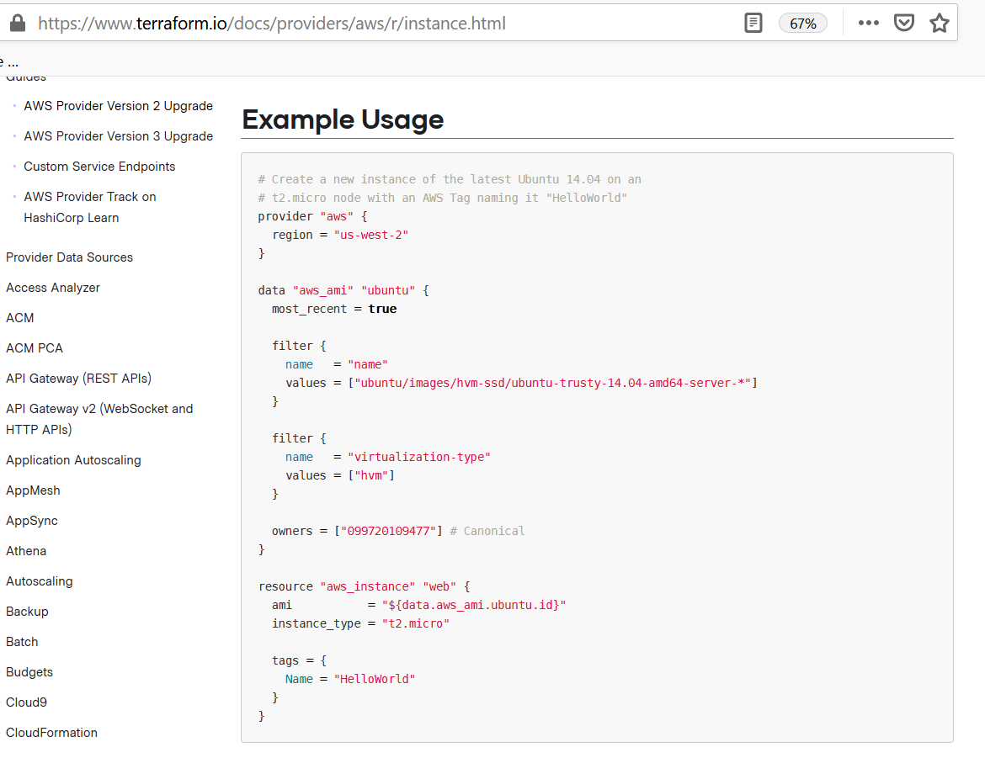

Open Visual Studio Code editor and create file of type .tf

Example below –

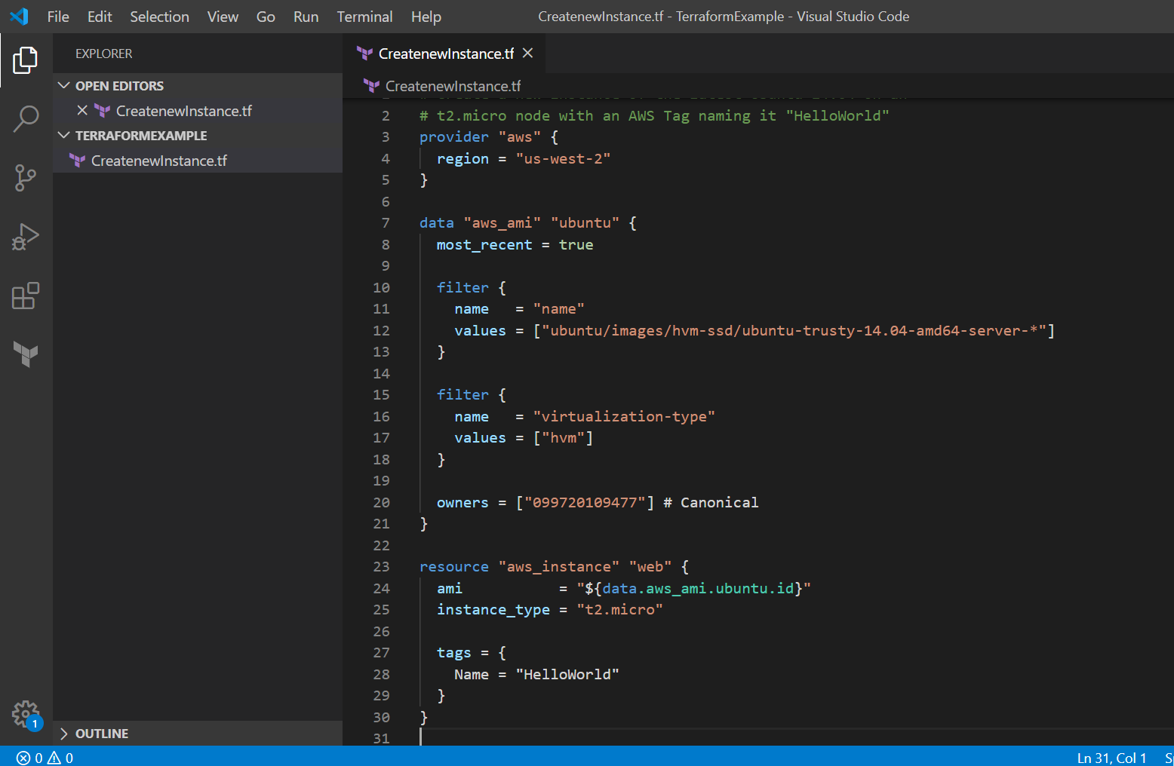

Delete below from terraform code and save.

owners = ["099720109477"] # Canonical

Open cmd and go to path

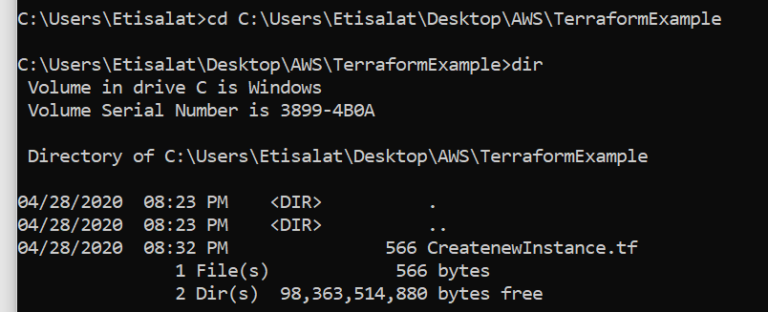

Run the command **terraform init**

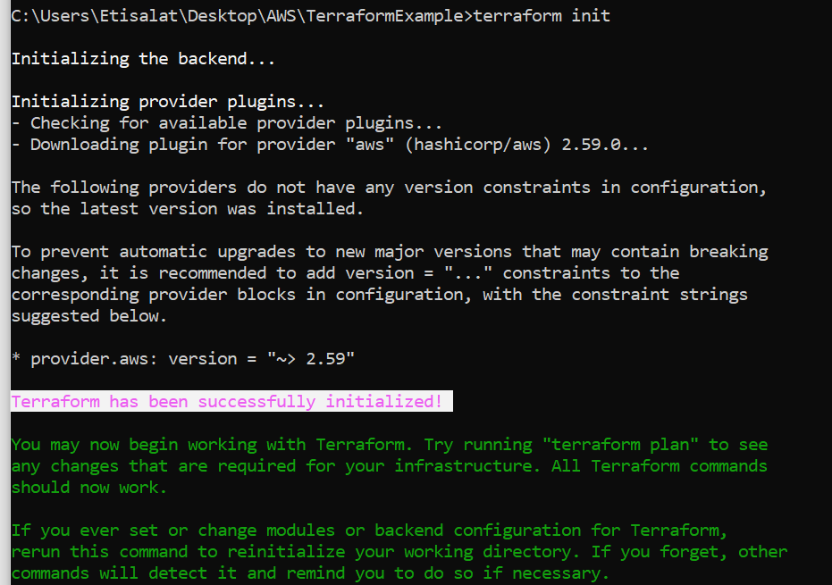

**You may now begin working with Terraform. Try running "terraform plan" to see**

**any changes that are required for your infrastructure. All Terraform commands**

**should now work.**

**If you ever set or change modules or backend configuration for Terraform,**

**rerun this command to reinitialize your working directory. If you forget, other**

**commands will detect it and remind you to do so if necessary.**

Now, Run the command **terraform plan**

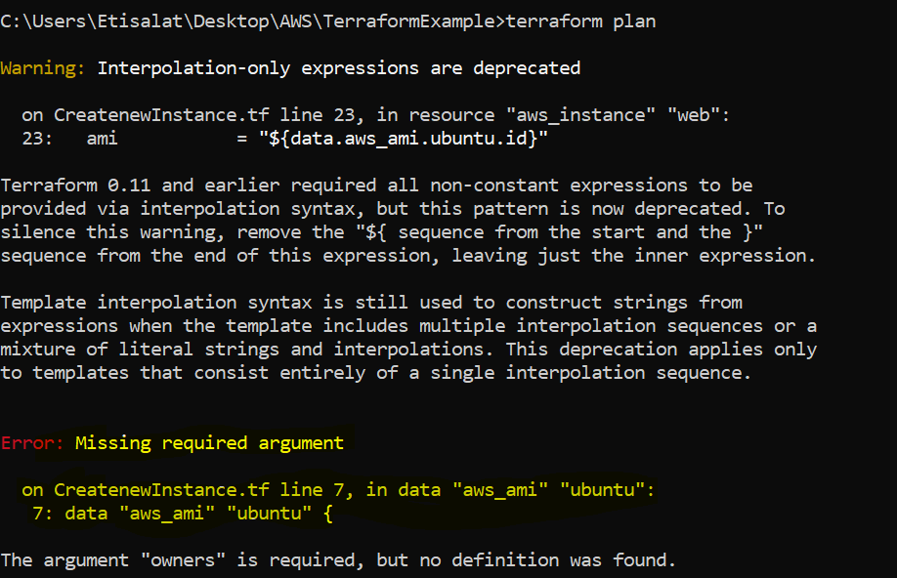

Error occurred, highlighted in upper screen shot and says add owners. So go to add owner as below in data section.

owners = ["099720109477"] # Canonical

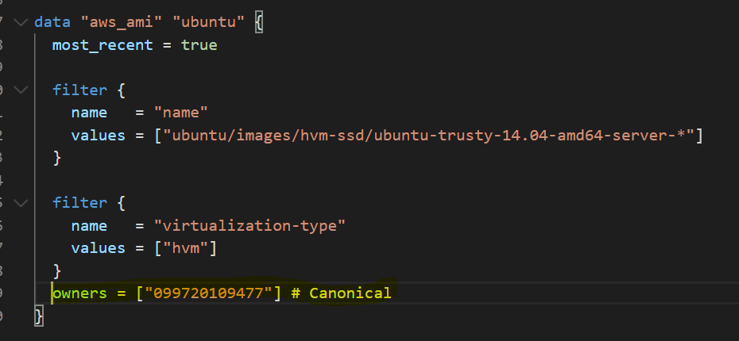

**Now Run terraform plan command again……..**

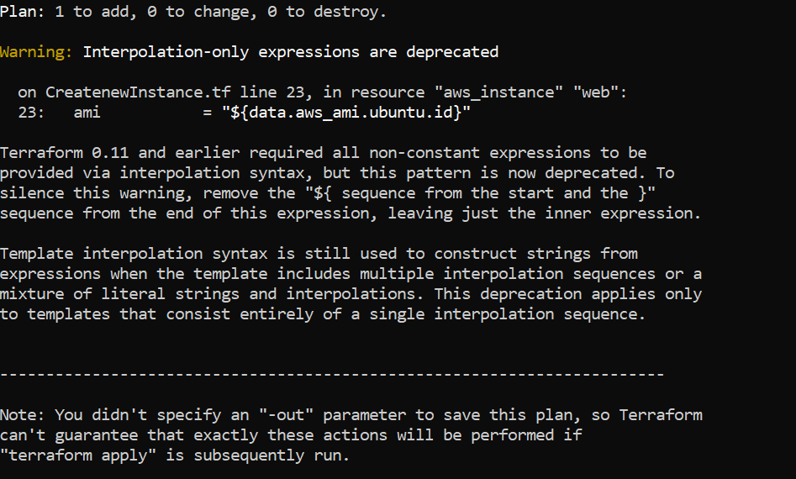

Now Run the command **terraform apply** to provision machine in aws.

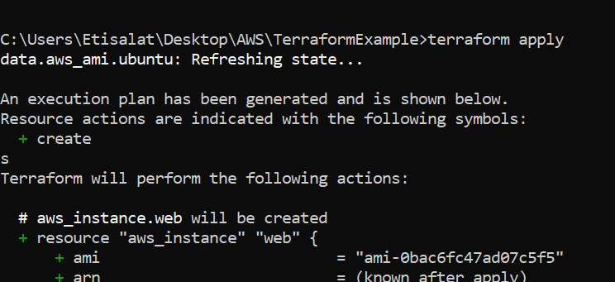

Enter Value: yes

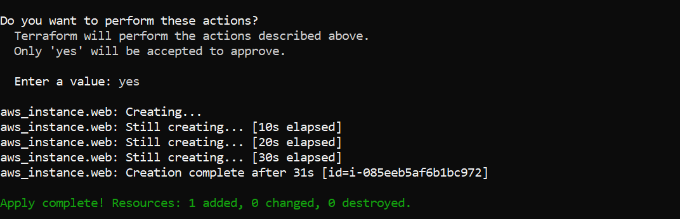

Instance has been created in AWS in region us-west-2